新建语音室系统操作简单说明:
New language laboratory system operation instructions:

（一）打开语音软件：
- 双击桌面图标打开软件
- 单击出现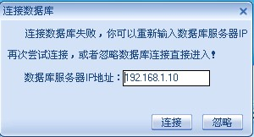然后单击按钮
- 最后单击进入综合教学界面。
To start the voice software:
1. Double-click the icon on the desktop.
2. Click the icon and then the icon after the icon appears
（二）系统使用
- 教师广播
按钮旁边有边框为选中状态，此时所有学生都可听到教师发音
- 提问一个学生（全班同学可听到此学生发音及教师发音）
先单击按钮让其处于选中状态，然后再单击需提问的座位号
- 提问两个学生以上（全部同学可听到这两位学生发音及教师发音）
先点然后单击选择座位号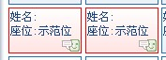
再点击下边的按钮，即可。点按钮结束示范
- 让学生显示器界面与教师同步
点这个按钮，不要则取消
- 播放声音文件、视频文件
在播放声音文件和视频文件时一定要打开语音软件，进入“综合教学”界面，然后把此软件最小化（点击软件右上角这个按钮）再打开需要的文件即可。
To use the system:
- The teacher’s broadcast:
When the frame appears around the icon, it is the selected state and all students can hear the teacher.
2. To call one student: (The other students can hear the talk between the teacher and the student.)
Click the icon and then click the student’s seat number.
- To call two or more students at the same time: (The other students can hear the talk between the teacher and the students.)
Click the icon, the students’ seat numbers and then the icon. Click the to end the talk.
- To synchronize the PC interfaces of the teacher and students:
Click the icon to synchronize the PC interfaces of the teacher and students.
- To play the sound files and video files:
Start the voice software before playing the sound files and video files; enter the“综合教学”(synthetic instruction) interface; play those files after minimizing the software. (click the software’s icon on the top right corner)

